BIO DATA

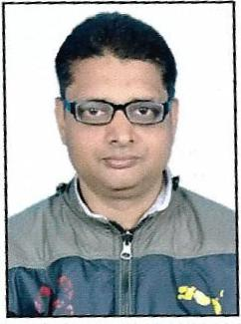
TO

THE RESPECTED DIRECTOR SIR / MARKETING MANAGER

Applicent:-ALOK SRIVASTAVA

Resi: 882, Shahapur urf Pipalgaon

(Inside of K. V. Road Near IIIT Hostel)

Jhalwa, Allahabad, U.P.- 211012

Mobile no: 7309077511,9389044419

Email Id: 10decalok@gmail.com

POST APLLY for:- ASSISTENCE(Medical representative or SALES REPRESENTATIVE]

WORKING PLACE:- ALLAHABAD ( WITH COVERING AREA NEARBY)

Career Objective:

Secure life with perfect honest hard working.

Work Experience:-

I WORKED IN MY RETAIL SHOP .

Educational Qualification:

- Post Graduate Diploma in Rural Development from IGNOU in 2003.
- M.A Passed From C.S.J.M University Kanpur in 2002.
- B.A Passed From University of Allahabad in 2000.
- Intermediate Passed From U.P. Board in 1996.
- HIGH SCHOOL passed From U.P. Board in 1994.

Personal Details:

Date of Birth : 10-Dec-1978

Father’s Name : Mr. Ashok Kumar Srivastava

Mother’s Name : Late Saroj Srivastava

Sex : Male

Height : 5’7”

Weight : 63Kg

Marital Status : Married

Languages known : Hindi, English

Nationality : Indian

Skills:

- 4/2W MOTOR DRIVING KNOW
- VERY ENERZETIC AND ATICATE
- COMPUTER KNOWLEDGE
- MEDICINE MARKETING KNOWLEDGE
- ITR/PAN CARD/PASSPORT MAKING KNOWLEDGE.
.

Declaration:

I do hereby declare that the above information provided by me is true and fair best of my knowledge.Sir request for please give me chance .
I Will be greatfull to you.
Date: 20/04/2018 Signature
Place: Allahabad (UP.)
(Alok Srivastava)

